**GOVERNMENT DEGREE COLLEGE, GUMMALAKSHMIPURAM**

**🩸 EVENT REPORT: BLOOD DONATION CAMP**

**📅 Date:** 27-11-2024  
**🏛️ Venue:** Government Degree College, Gummalakshmipuram  
**🎯 Organized By:** NSS Unit I & II  
**👨‍⚕️ Guest of Honor:** Dr. T. Sreevaram, Principal  
**🤝 In Collaboration With:** District Blood Bank (DDB), Parvathipuram

**Objective of the Event:**

The **Blood Donation Camp** was organized with the aim of promoting **voluntary blood donation** and sensitizing students to the importance of contributing towards saving lives. It was a part of NSS’s commitment to community health and social responsibility.

**Highlights of the Programme:**

* The camp was **formally inaugurated** by the **Guest of Honor**, **Dr. T. Sreevaram**, Principal of the college, who addressed the gathering and emphasized the **noble cause of blood donation**. She encouraged students to become regular donors and thanked the NSS volunteers for their initiative.
* The event was conducted in **association with the District Blood Bank (DDB), Parvathipuram**, and supported by the **Community Health Centre (CHC), Kurupam**.
* **Medical professionals**, including doctors and technicians from DDB and CHC, carried out the blood collection process in a highly hygienic and professional manner.
* A **total of 78 units of blood** were collected during the camp, with enthusiastic participation from **students, staff members, and local volunteers**.
* The **Circle Inspector of Elwinpeta Police Station** attended the event as a special guest and **appreciated the efforts of all the donors and organizers**, highlighting the role of youth in public service and humanitarian activities.
* Proper **screening of donors** was ensured before blood collection. Donors were provided with **refreshments and appreciation certificates**.

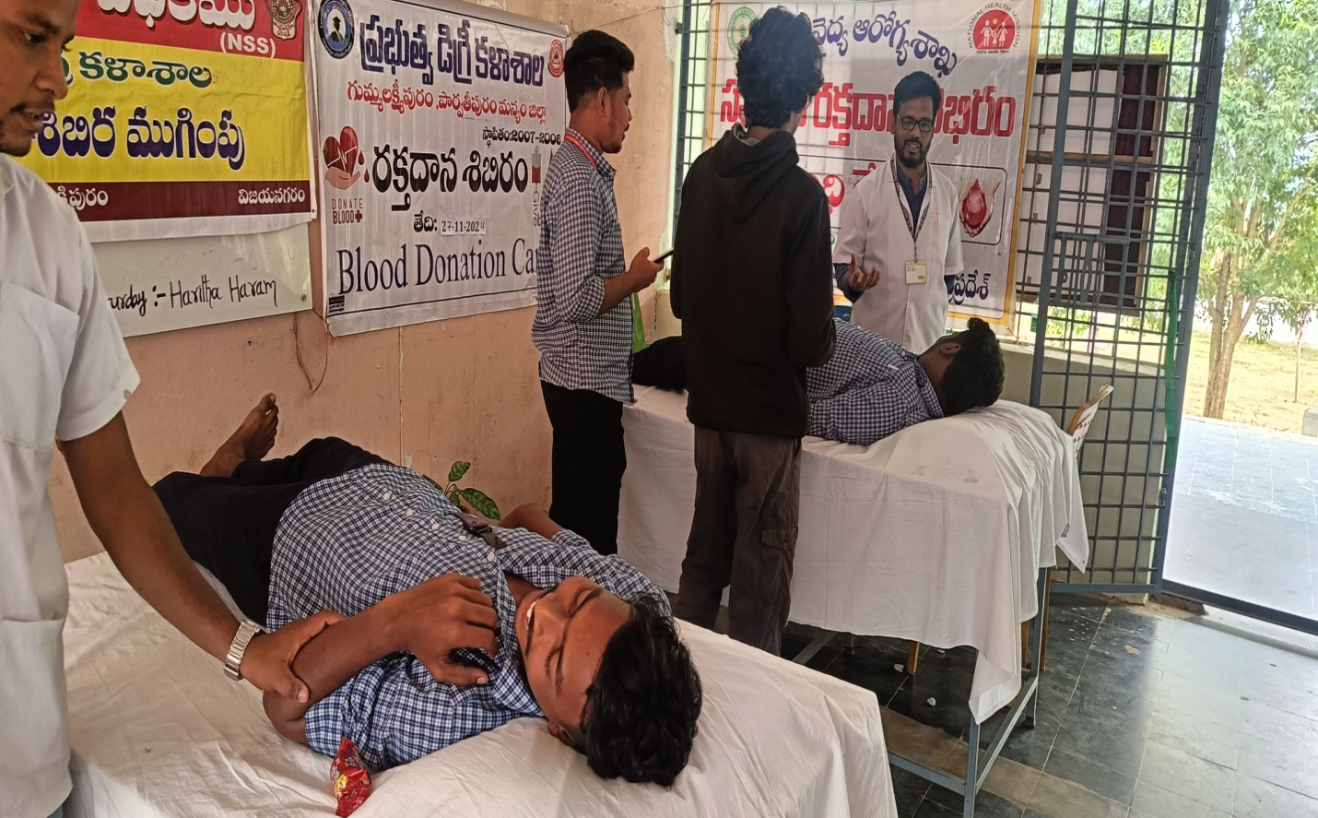

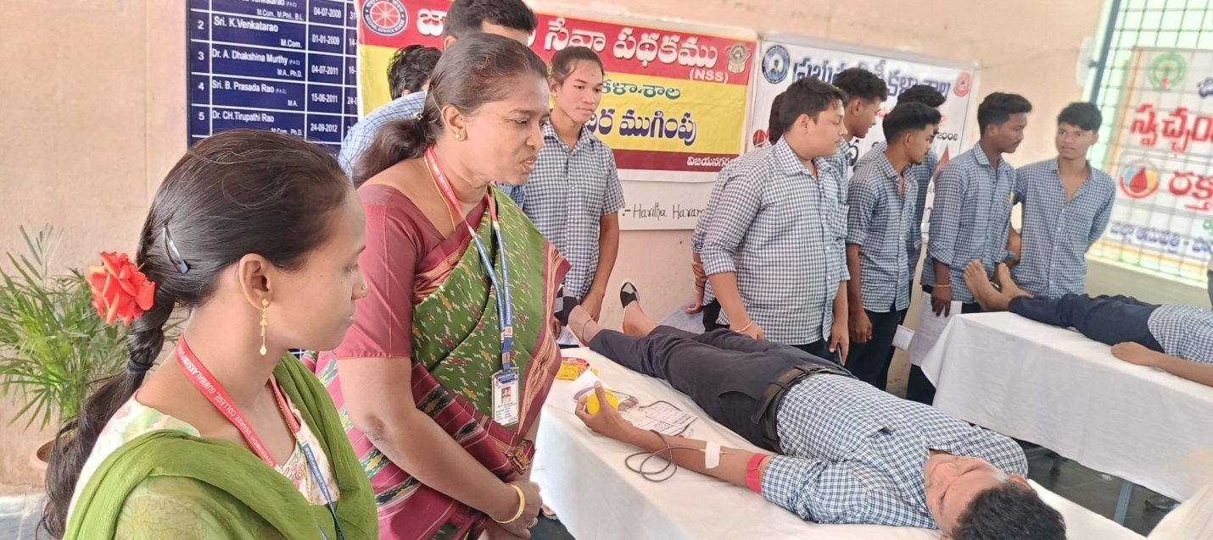

**Significance of the Event:**

This initiative not only addressed the urgent **demand for safe blood** in the district but also instilled a **sense of social responsibility and empathy** among students. It was a meaningful platform for **youth engagement in health-related causes**.

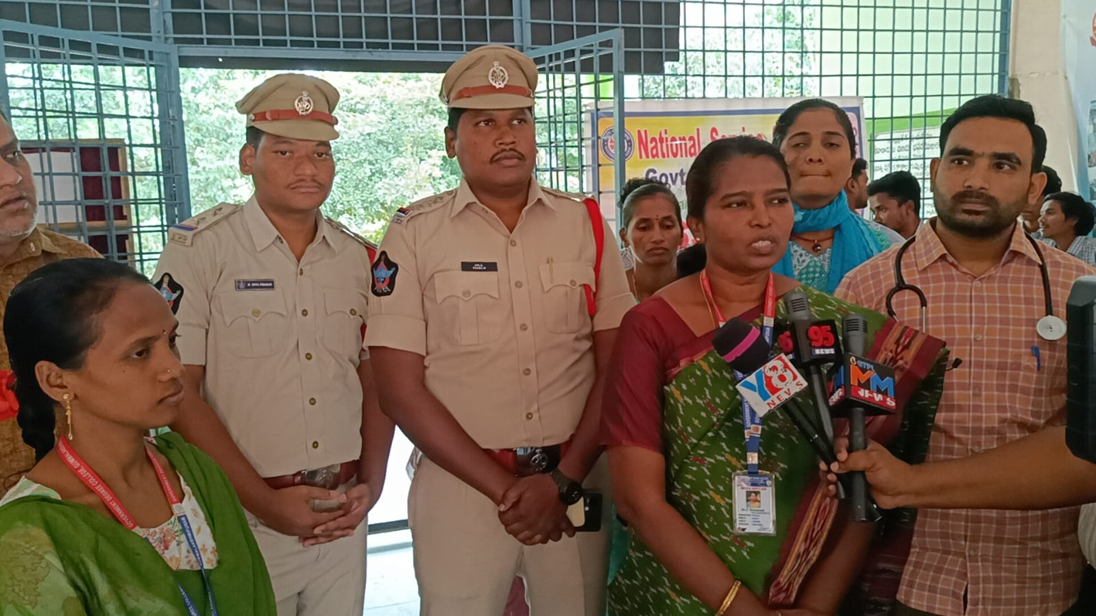

**Acknowledgements:**

The Department of NSS extends sincere thanks to:

* **Dr. T. Sreevaram**, Principal, for her unwavering support and motivation
* **Medical Team from DDB Parvathipuram and CHC Kurupam**
* **Police officials of Elwinpeta Circle**
* **All student volunteers, donors, and NSS Programme Officers**

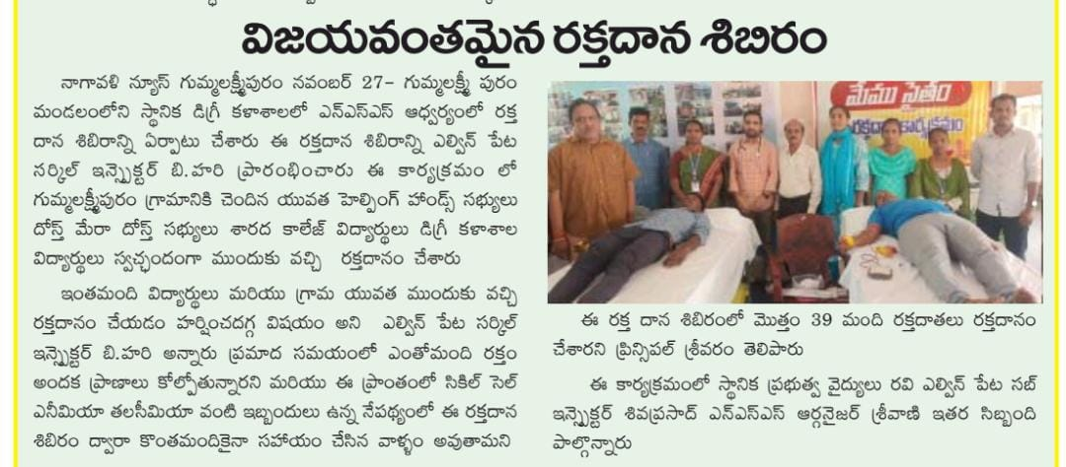

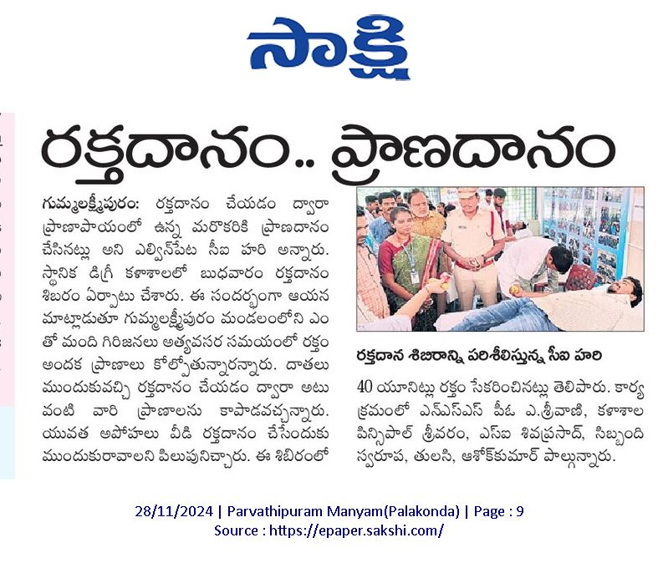

**Conclusion:**

The **Blood Donation Camp** was a grand success and received heartfelt appreciation from all quarters. It demonstrated the spirit of **unity, compassion, and active citizenship** among the students and reinforced the role of educational institutions in **public health outreach**.